## Write a program to find whether a given year is a leap year or not.

function leapyear (year) {

return (year % 100 == 0) ? (year % 400 == 0) : (year % 4 == 0);

}

console.log(leapyear(2016));

console.log(leapyear(2000));

console.log(leapyear(1700));

console.log(leapyear(1800));

console.log(leapyear(100));

***Running this in VsCode***

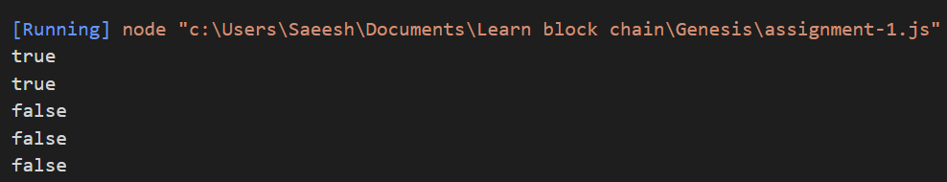

## Write a JavaScript program to convert temperatures to and from Celsius, Fahrenheit

[ Formula : c/5 = (f-32)/9 [ where c = temperature in Celsius and f = temperature in Fahrenheit ]

*Expected Output :*

60°C is 140 °F

45°F is 7.222222222222222°C

function cTof (celcius) {

var cTemp = celcius;

var cToFahr = cTemp * 9 / 5 + 32;

var message = cTemp + '\xB0C is ' + cToFahr + '\xB0F.';

console.log(message);

}

function fToc (fahrenheit) {

var fTemp = fahrenheit;

var fToCel = (fTemp - 32) * 5/9;

var message = fTemp + '\xB0F is ' + fToCel + '\xB0C';

console.log(message);

}

cTof (60);

fToc (45);

***Running this in VsCode***



## Write a program to find the factorial of a number

function factorial(n) {

let answer = 1;

if (n == 0 || n == 1) {

return answer;

}else{

for(var i = n; i >=1; i--){

answer = answer * i;

}

return answer;

}

}

let n = 4;

answer = factorial(n);

console.log("The answer of factorial " + n + " is " + answer);

